A000-Asia-China-Shang-You Vessel-Elephants-Bronze-c 1250-1046 BCE

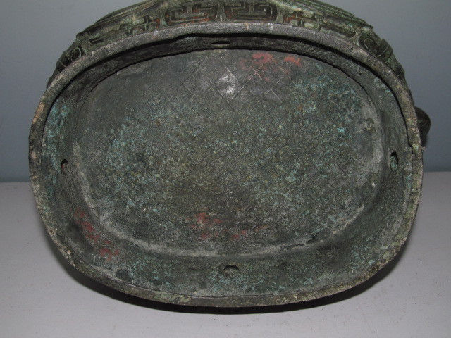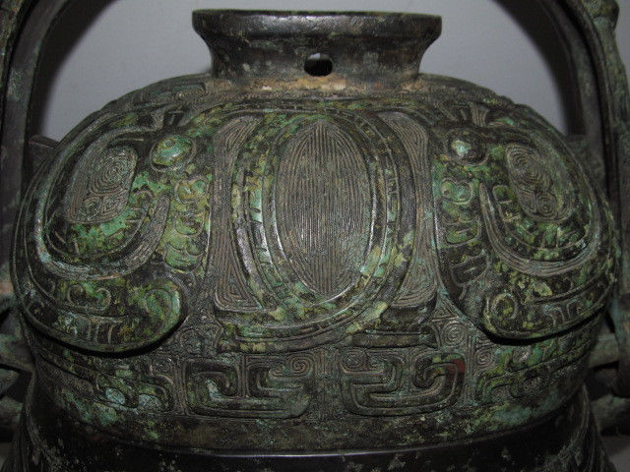

Two fantastic elephant-like beasts.

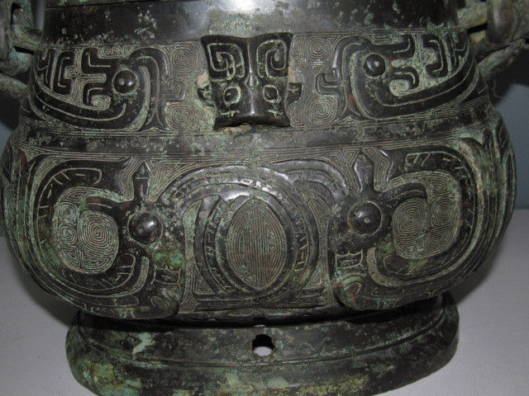

Two dragons flanking a bovine mask above a fantastic elephant –like beast.

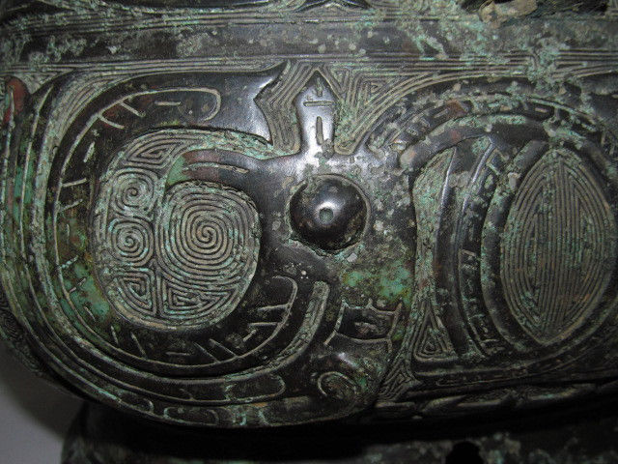

Fantastic elephant-like beast with two trunks but no tusks.

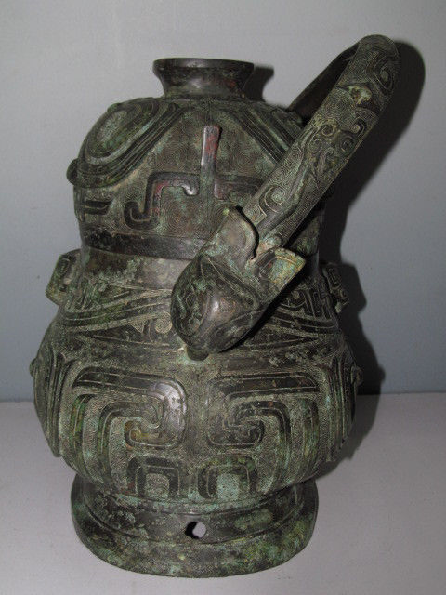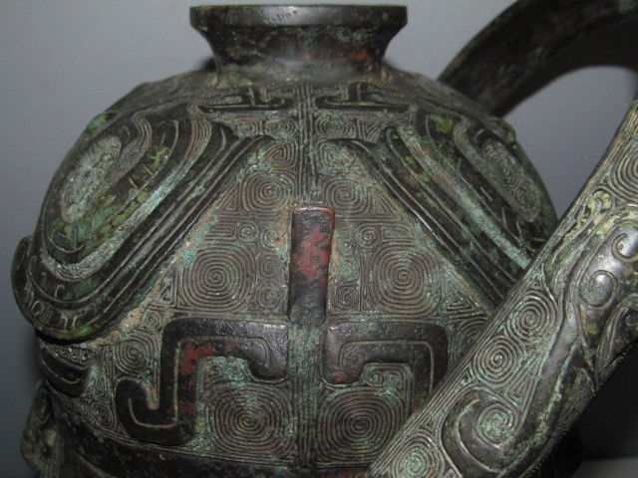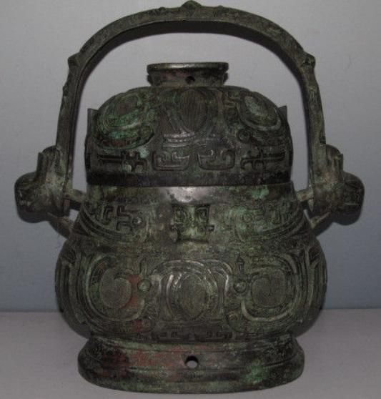

Figs. China-Shang-You Vessel-Elephants-Bronze-c 1250-1046 BCE

**Case No.: 5**

**Accession No.**

**Formal Label:** China-Shang-You Vessel-Elephants-Bronze-c 1250-1046 BCE

**Display Description:**

Archaic bronze ritual wine vessel or You is from the Shang Dynasty, Yinxu Period. Featuring Fantastic Elephants-Bronze-c 1250-1046 BCE

This finely and lavishly decorated bronze wine vessel is both in shape and decoration a perfect representative of the high and , mature ‘Anyang’ style that flourished from the mid-Shang period (c. 1600 – c. 1046 BC) in the then-capital of Yinxu in present-day Henan province. Although it displays the classic proportions of you of that period and exhibits the archetypal taotie design, it is very rare in its combination of these formal and decorative features, and it is difficult to find close counterparts. The remarkable condition of the piece further adds to its importance in the surviving canon.

You were used as wine containers at ancestral rituals. Wang Tao writes (*Chinese Bronzes from the Meiyintang Collection*, London, 2009, p. 62) that ‘in Shang oracle bone inscriptions and Western Zhou bronze inscriptions, we read that a vessel named “You” was employed as a bucket for aromatic wine used for sacrifice’. "The shape was in use since the later Erligang period (c 1600-1400 BCE Robert W. Bagley (*Shang Ritual Bronzes in the Arthur M. Sackler Collections*, Washington, D.C., 1987, p. 374), wine vessels found in the tomb of Fu Hao, consort of King Wu Ding, the only undisturbed royal Shang tomb at Anyang so far, which has been variously dated from 1250 to c. 1200 BCE, “do not include oval-bodied you, suggesting that the type did not appear until after the first century of the Anyang period”.

The basic form of the present vessel, of pointed oval section, which became popular in the 12th and early 11th centuries BC, was modified again in the Western Zhou period (c. 1046 – 771 BC), when its profile became more compact and its oval section more squared. Yet this Shang form itself could be adjusted in so many ways that the variety of forms is breath-taking: contemporary examples can differ in proportion, section and profile, the alignment and shape of the handle, the shape of the knob, and the existence and shape of flanges. In addition, there were many ways to decorate such vessels. Two basic types seem, however, to be prevalent, one with overall decoration, but differing from this You in many respects; the other only partly decorated,

You with overall decoration are usually of broader, more exaggerated pear shape, the designs executed in higher relief, paired with more prominent "angles and wing-like hooks on either side of the cover. The handle is usually cast with animal heads in the round that hide the loops for attachment, and it may even be attached the opposite way, running from front to back. You of this type from the Sackler collection are illustrated in Bagley, op. cit., pls.64 and 65, with excavated and heirloom counterparts, Figs. 64.2, 64.3, 64.4 and 64.6.

The more ovoid form of the present you and its linear decoration are closer to late Shang examples that are lacking the "angles and are decorated only with narrow bands of design around cover, shoulder and foot, leaving the main part of the body plain. On such you, the handle tends to have simple, openly visible loops without animal masks, seemingly similar to the present piece, although this You does bear masks on either side, albeit in miniature. Bagley also illustrates and discusses a range of such more sparsely decorated you of the late Shang period from the Sackler collection, op. cit., pls. 68-70, and comparisons, mostly excavated, Figs 68.5, 70.2, 70.3, 71.2 and 71.3.

**LC Classification:**

**Date or Time Horizon:** c 1250-1046 BCE

**Geographical Area:**

**Map:**

**GPS coordinates:**

**Cultural Affiliation:**

**Media:**

**Dimensions: L 15 in W 9 in H 16 in**

**Weight: 15 kg**

**Condition:**

**Provenance:**

**Discussion:**

**References:**

Bagley, Robert W. 1987. *Shang Ritual Bronzes in the Arthur M. Sackler Collections*. Washington, D.C.: Smithsonian Institution.

Tao, Wang. 2009. *Chinese Bronzes from the Meiyintang Collection*, London.